**Course: Business Analysis and Assessments**

**Assignment 3**

**Executive Dashboard**

|  |  |
| --- | --- |
| Submitted By: | Nishanth Maria Arul Dhasan (100813350) |
| Submission Date: | 2022-08-10 |

**Chapter -1**

**Introduction**

Coffee is the most popular drink in the world and some claim it to be the most consumed. But the big question is, “Does coffee tastes the same everywhere?” If that is the case, there’s no point for companies to invest in millions. The answer is ‘No’. The taste of a cup of coffee depends on not only the quality of the beans, but also the way in it was prepared and served.

The Coffee Cup is a Canadian owned business which is in the hospitality industry. They are a chain of coffee shops which aim to satisfy the tastebuds of coffee enthusiasts and tea lovers. They sell a variety of coffee and speciality tea.

**Vision:**

To provide a next-door coffee shop experience to our patrons at a fair price.

**Mission:**

To provide the world’s ultimate coffee shop experience with the highest-quality products, most

inviting stores, friendliest staff and best value.

**The Task:**

The Senior management at The Coffee Cup has provided a dataset which contains the information from 2018 and 2019. The task at hand is to analyze the data and provide much needed answers.

**Chapter - 2**

**Analysis**

**Data Cleaning:**

The first thing to do before the analysis of data is the cleaning of the data. Data Cleaning is the process in which the incorrect, wrong and repeated values are either deleted or filled with suitable values (Tableau, 2022). For cleaning the dataset, MS Excel is used in this case as it seemed to be the better option (Robert, B. (2022), DATA1205: Week 07). The data needed a lot of cleaning. The cells with null values were removed throughout the files and are either replaced with appropriate values like mean or they were simply deleted, provided it did not affect the dataset (Robert, B. (2022), DATA1205: Week 07). Apart from that, the format of the geographical data like cities and states were in string. They were changed to geographical data. After this, Prince Edward Island, was not recognized as a geographical variable because, it was stored as PEI. So, it was deleted and changed to Prince Edward Island. Moreover, the date was also stored as a string variable, which was changed to date. New columns were added for adding new fields. The new columns added were

* Inventory Turnover
* Gross Profit
* Gross Marginal Rate of Interest (GMROI)

**Inventory Turnover:**

Inventory turnover can be defined as the ratio of the sales to the average inventory (Fernando, 2022). It shows how many times the inventory is sold and refilled during a given period of time (Mascolo, 2020).

**Gross Profit:**

Gross Profit is the difference between the net profit and the cost of goods sold (Hayes, 2022).

**Gross Margin Return on Investment:**

GMROI is the ratio of gross profit to the average inventory cost. It is used to determine the amount of money to be invested in inventory for generating the gross margin dollars (Mascolo, 2020).

This is the modified dataset which is to be used for the analysis.

**Quality:**

Though the contents of the dataset are sufficient for the analysis, it did have a lot of errors which needed correction.

**Visualization 1: Sales and Profit Comparison**

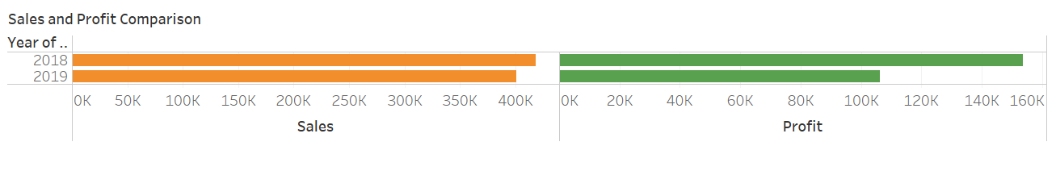

A horizontal bar chart is used for this data. This is the best suited visualization because, it is easy to read and with a quick look, the brain will register the essence of the plot by comparing the end points of the bars from smallest to biggest (Knaflic, 2015). In this visualization, the sales and profit for the years 2018 and 2019 are compared. Of the two years, the year 2018 was profitable. This shows that there is a decline in sales and profit in 2019.

**Visualization 2: Inventory Turnover – 2018**

Inventory turnover shows how many times in a given period of time, the inventory is sold and refilled (Mascolo, 2020). A higher inventory turnover ratio shows strong sales and lower ratio shows weak sales (Jenkins, 2022).

Here, we have plotted inventory turnover ratio against product type for the year 2018. This shows that Espresso has the highest inventory turnover ratio with 27.2% and Tea has the lowest inventory turnover ratio with 21.1%. This shows that Espresso is the fast-moving product whereas Tea is the least moving product.

**Visualization 3: Inventory Turnover – 2019**

Here, we have plotted inventory turnover ratio against product type for the year 2019. This shows that Espresso has the highest inventory turnover ratio with 27.1% and Tea has the lowest inventory turnover ratio with 21.1%. This shows that Espresso is the fast-moving product whereas Tea is the least moving product.

**Visualization 4: GMROI – 2018**

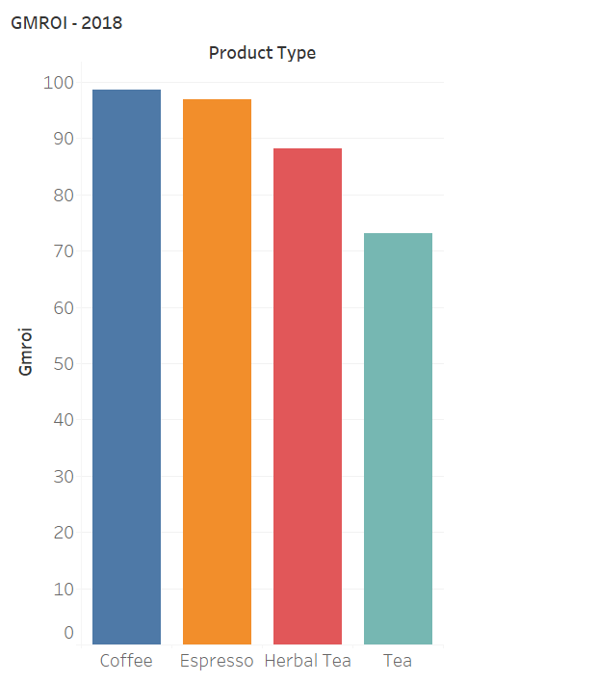

The gross margin returns on investment or GMROI is a metric used to analyze the capability of a company to turn the inventory into money exclusive of the cost of inventory (Kenton, 2021). A higher GMROI denotes a higher return, whereas a lower GMROI signifies a lower profit.

In this case, we have plotted the product type against GMROI for the year 2018. This shows that coffee has the highest GMROI with 98.64 and Tea has the lowest inventory turnover ratio with 72. This shows that coffee produces higher return on investment than any other product whereas Tea produces the least.

**Visualization 5: GMROI – 2019**

In this case, we have plotted the product type against GMROI for the year 2019. This shows that coffee has the highest GMROI with 81.12 and Tea has the lowest inventory turnover ratio with 60.9. This shows that coffee produces higher return on investment than any other product whereas Tea produces the least.

**Visualization 6: Profit vs Money Spend on Marketing**

In the first graph, the products are compared with the money spent on marketing. In the second graph, the profit generated by the products are plotted. Both charts can be compared with each other to find out if the money is worth spending on marketing. Here, huge money is spent on espresso and coffee for marketing, and they bring in returns. At the same time, the profit generated by green tea is too low and is so less when compared to the amount spent on marketing.

**List of Questions the Data Can Answer:**

1. Do the sales depend on the size of market?
2. Is the business growing?
3. Has spending in marketing paid off for each product?
4. Which product can be discontinued in order to save money?
5. What province has the highest sales?
6. Which market leads in sales?
7. Which product is the most sought out?
8. Is the company generating sufficient income from inventory?
9. Is the inventory turnover ratio on the good level?
10. Has the company generated higher profit in 2019 than 2018?

**List of Questions the Data Cannot Answer:**

1. What can be done to improve the business?
2. Which province has the highest per capita sales?
3. Which market is bigger when population is taken into account?
4. What is the value of items sold per customer?
5. What is the aging inventory?

**Recommendations:**

**Data to Enhance the Dataset:**

In order to answer the questions above, certain metrics should be added to the dataset which will enhance the dataset further. This will help in further deep exploration of the dataset and as a result, insights could be gathered.

For calculating the per capita sales, a population data for either the states or the market is required. With the population data, questions 2 and 3 could be answered. For calculating the items per customer, the number of transactions data is required.

The dataset does not have any data description. That is, we do not know, if the budget, profit, etc. are in dollars or any other units. So, if it was clear, it would have been easier and comfortable to analyze the data.

**Conclusion:**

* After comparing 2018 and 2019, it could be seen that the sales are lesser in 2019 and the margin is only around $10,000. But the profit margin between these two years is around $50,000, which shows that there is a rise in expenses.
* The inventory turnover and GMROI are good.
* Even though more money is spent on marketing for certain products, the returns are less which begs the question if the company should sell that product anymore.

**Chapter – 3**

**Strategy Map**

A strategy map illustrates the four areas where an organization should excel at in order to succeed in executing its strategy. The four perspectives of a strategy map are finance, process, internal, learning and growth (Rivera, n.d.).

The Key Performance Indicators in our case are, Cost of Goods, Coffee Store Performance, Customer Loyalty, Profits and Sales, Product Inventory and others.

|  |  |
| --- | --- |
| Strategic Goals | Brand Formation  Increase in Profit  Market Share Increase |
| Financial |  |
| Customer |  |
| Internal |  |
| Learning and Growth |  |

**Chapter – 4**

# **References**

Fernando, J. ( 2022, June , 27). *Inventory Turnover*. Retrieved from investopedia: https://www.google.com/url?sa=t&rct=j&q=&esrc=s&source=web&cd=&cad=rja&uact=8&ved=2ahUKEwi78rzn3br5AhWblIkEHf_dAhAQFnoECBcQAQ&url=https%3A%2F%2Fwww.investopedia.com%2Fterms%2Fi%2Finventoryturnover.asp&usg=AOvVaw1rvoNRGlSLb8bD4KcAHz0W

Hayes, A. ( 2022, July, 25). *Gross Profit*. Retrieved from investopedia: https://www.investopedia.com/terms/g/grossprofit.asp

Jenkins, A. ( 2022, August , 9). *Inventory Turnover Ratio Defined: Formula, Tips, & Examples*. Retrieved from Oracle netsuite: https://www.netsuite.com/portal/resource/articles/inventory-management/inventory-turnover-ratio.shtml

Kenton, W. ( 2021, March 30,). *What Is the Gross Margin Return on Investment (GMROI)?* . Retrieved from investopedia: https://www.investopedia.com/terms/g/gmroi.asp

Mascolo, F. ( 2020, Jun , 28). *Exploring a Retail Data Set as an Investor*. Retrieved from towardsdatascience: https://towardsdatascience.com/exploring-a-retail-data-set-as-an-investor-1b08e5c7b255

Rivera, M. P. (n.d.). *What is a strategy map (& do you need one)?* Retrieved from clearpoint strategy: https://www.clearpointstrategy.com/what-is-a-strategy-map/

Tableau. (2022). *Guide To Data Cleaning: Definition, Benefits, Components, And How To Clean Your Data*. Retrieved from tableau.com: https://www.tableau.com/learn/articles/what-is-data-cleaning

Robert, B. (2022). DATA1205: Week 07 [PowerPoint slides]. DCConnect. https://durhamcollege.desire2learn.com/

Robert, B. (2022). DATA1205: Week 05 [PowerPoint slides]. DCConnect. https://durhamcollege.desire2learn.com/

Knaflic, C. N. (2015). Storytelling with data: A Data Visualization Guide for Business Professionals. John Wiley &amp; Sons, Inc.